Central Catholic Eagles Football
2023

8/31/2023 TH Central Private (Baker, LA) Home 7:00
9/8/2023 Abbeville Away 7:00
9/15/2023 Riverside Away 7:00
9/22/2023 Covenant Christian * Away 7:00
9/28/2023 TH Jeanerette * Home 7:00
10/6/2023 Centerville * (Homecoming) Home 7:00
10/13/2023 Berwick Away 7:00
10/20/2023 Hanson * Away 7:00
10/26/2023 TH Vermilion Catholic * Home 7:00
11/3/2023 Highland Baptist * Away 7:00

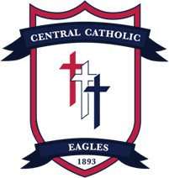
District Games *

Head Coach: C.L. Grogan Jr.
Athletic Director: Ree Case
Principal: Pete Boudreaux

